**WEEK 03**

1. ***Create an Employee table with the following attributes and constraints:***

***Employee Table - (Employee Id. (Primary key), Name, Department, Age (check >18), Salary, City).***

CREATE TABLE IF NOT EXISTS Employee (

  EmployeeId INT PRIMARY KEY,

  Name VARCHAR(100),

  Department VARCHAR(100),

  Age INT CHECK (Age > 18),

  Salary DECIMAL(10, 2),

  City VARCHAR(100)

);

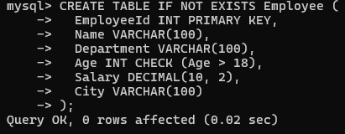

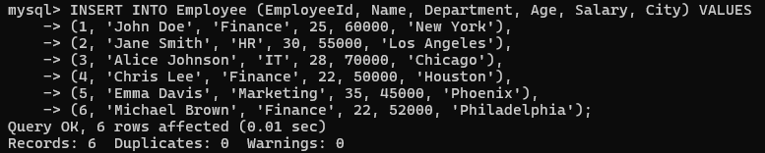

1. ***Display the total number of employees.***

SELECT COUNT(*) AS TotalEmployees FROM Employee;

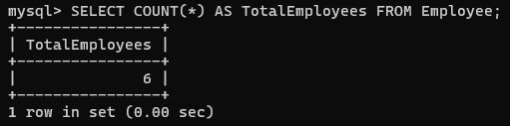

1. ***Retrieve all information of employees whose age is 22.***

SELECT * FROM Employee WHERE Age = 22;

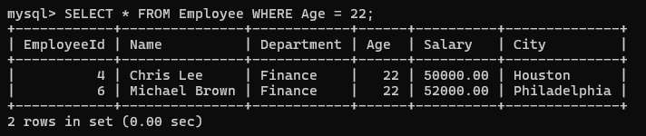

1. ***Fetch the employee id, name, and department, whose salary >= 50000.***

SELECT EmployeeId, Name, Department FROM Employee WHERE Salary >= 50000;

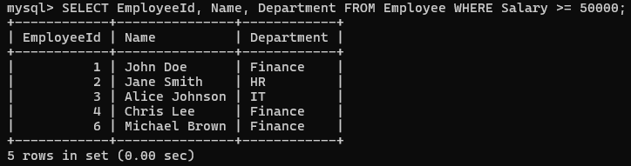

1. ***Print the name of the employees and label the column as 'Full Name' for those employees whose department name is 'Finance' and age is 22.***

SELECT Name AS 'Full Name' FROM Employee WHERE Department = 'Finance' AND Age = 22;

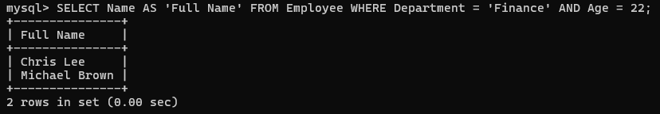

1. ***Print the department names from the employee table without having the duplicates.***

SELECT DISTINCT Department FROM Employee;

